- Create a new folder named insta-analytics and organize it using the recommended DA project structure: include data/raw, data/processed, notebooks, scripts, dashboards, reports, and a README.md file. Add a sample CSV file (can be empty) to data/raw and a sample Jupyter notebook (can be empty) to notebooks.

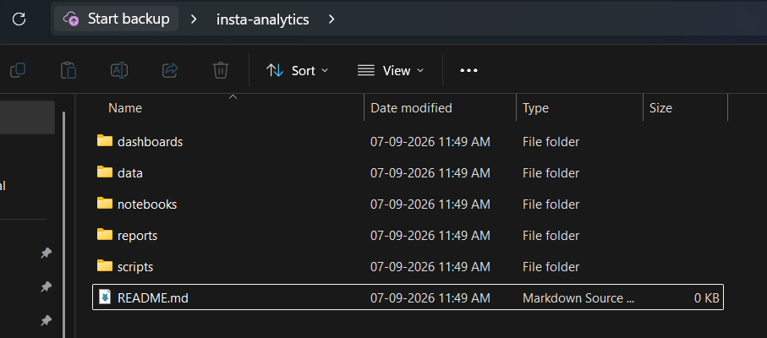

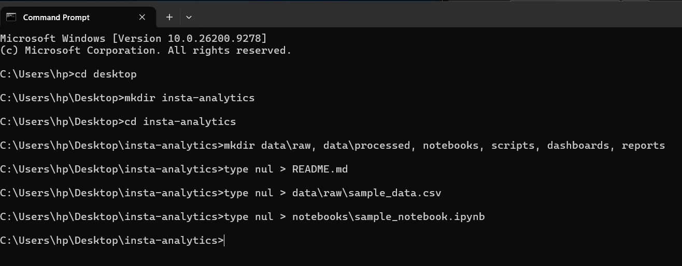

- Set up a ml-project folder for a 'Spotify Song Popularity Predictor' using the ML folder structure: data, src, notebooks, models, saved_artifacts, and README.md. Place a dummy text file in each subfolder to verify the structure.
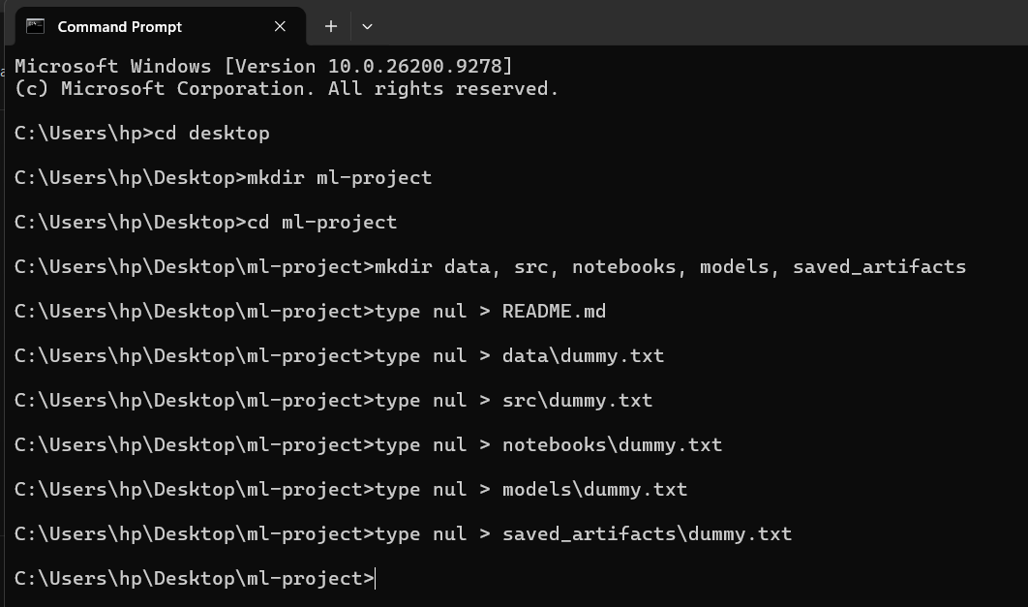

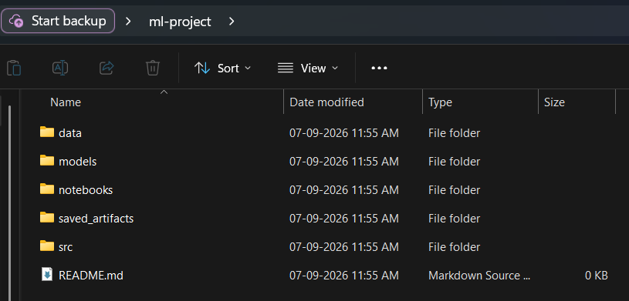

ml-project/
│
├── data/
│ └── dummy.txt
│
├── src/
│ └── dummy.txt
│
├── notebooks/
│ └── dummy.txt
│
├── models/
│ └── dummy.txt
│
├── saved_artifacts/
│ └── dummy.txt
│
└── README.md

- Write a .gitignore file for your insta-analytics project that ignores all files in data/raw, any .ipynb_checkpoints folders, and any files ending with .h5 or .pkl. Use wildcards and folder paths to match these patterns.

How to use it:
- Inside your root insta-analytics folder, create a new file named exactly .gitignore (make sure it starts with a dot and has no extension like .txt).
- Paste the following lines inside it and save the file:
Plaintext
# Ignore all files inside the data/raw folder
data/raw/*

# Ignore Jupyter notebook checkpoint folders anywhere in the project
.ipynb_checkpoints/

# Ignore model or data binary files ending with .h5 or .pkl
*.h5
*.pkl
Explanation of the Rules:
- data/raw/*: Ignores any files placed inside the raw data directory so large datasets don't get accidentally pushed to GitHub.
- .ipynb_checkpoints/: Automatically catches and ignores hidden Jupyter checkpoint folders, no matter which subfolder they appear in.
- *.h5 & *.pkl: Global wildcards that ignore any file ending in these extensions (commonly used for saved machine learning models and Python pickles).

- Draft a professional README.md for your 'Spotify Song Popularity Predictor' folder. Include a project summary, a placeholder link for the dataset, setup instructions (e.g., required Python libraries), and a section for results & visuals (can use a sample image or text for now).

# 🎵 Spotify Song Popularity Predictor

A machine learning project designed to analyze audio features and metadata of Spotify tracks to predict their popularity score. This project aims to help artists, producers, and labels understand what musical characteristics drive a song's success on streaming platforms.

---

## 📌 Project Summary
As the music streaming market grows increasingly competitive, understanding the drivers behind a track's popularity is critical. This project leverages Spotify track features (such as acousticness, danceability, energy, tempo, and valence) to build and evaluate predictive regression/classification models.

### Key Objectives:
* Perform Exploratory Data Analysis (EDA) on track attributes.
* Preprocess and scale audio and metadata features.
* Train and benchmark machine learning models (e.g., Random Forest, XGBoost, Linear Regression).
* Deploy a clean structure for reproducibility and scalable artifact management.

---

## 📊 Dataset
The dataset used for this project contains track-level metrics extracted via the Spotify Web API.
* **Data Source:** [Download/Access the Dataset Here (Placeholder Link)](https://example.com/placeholder-spotify-dataset)
* **Raw Storage:** Place your raw CSV files inside the `data/` directory before running notebooks or scripts.

---

## 🛠️ Project Structure
```text
ml-project/
│
├── data/ # Raw and processed datasets
├── src/ # Source code for data ingestion, training, and evaluation
├── notebooks/ # Jupyter notebooks for EDA and experimentation
├── models/ # Saved trained model binaries (.pkl, .h5)
├── saved_artifacts/ # Visualizations, evaluation metrics, and logs
└── README.md # Project documentation
--------------------------------------------------------------------------------------------------------------------------
1. Clone the Repository
Bash
git clone [https://github.com/your-username/ml-project.git](https://github.com/your-username/ml-project.git)
cd ml-project
--------------------------------------------------------------------------------------------------------------------------

2. Create and Activate a Virtual Environment
Bash
# Using venv
python -m venv venv
source venv/bin/activate # On Windows use: venv\Scripts\activate
--------------------------------------------------------------------------------------------------------------------------
3. Install Required Dependencies
Install the necessary Python libraries for data processing and machine learning:
Bash
pip install numpy pandas scikit-learn matplotlib seaborn jupyter xgboost
--------------------------------------------------------------------------------------------------------------------------
📈 Results & Visualizations
(Preliminary results will be updated as model training progresses)

Feature Correlation Heatmap: Analyzes the relationship between audio energy, valence, and overall track popularity.

Model Performance Metrics:

Baseline RMSE: TBD

Optimized Model RMSE: TBD

Sample Visual Placeholder:

- Clone a trending open-source data science project from GitHub (not the one built in class), inspect its folder structure, and list 3 ways it follows or differs from the recommended DA/DS structure. Suggest one improvement you would make to its organization.

cookiecutter-data-science/
├── LICENSE
├── Makefile
├── README.md
├── data/
│ ├── external/
│ ├── interim/
│ ├── processed/
│ └── raw/
├── docs/
├── models/
├── notebooks/
├── references/
├── reports/
│ └── figures/
└── src/

3 Ways It Follows or Differs from the Recommended DA/DS Structure
- Follows (Multi-Tier Data Organization):
  - Details: It enforces a rigorous multi-stage data architecture (data/raw, data/interim, data/processed). This matches standard DA/DS practices by ensuring raw datasets are never overwritten and transformations are traceable.
- Follows (Decoupling Code from Exploration):
  - Details: It strictly separates exploratory code (notebooks/) from production-ready source scripts (src/), preventing messy notebook-driven monolithic scripts.
- Differs (Dedicated Reference Documentation):
  - Details: Unlike minimalist structures that only include a README.md, this repository includes a dedicated references/ folder explicitly meant for data dictionaries, manuals, and external business logic documents.
Suggested Improvement
Add a Centralized Configuration (configs/) Folder:
- The Gap: While the project has a src/config.py module, modern data science workflows often deal with dozens of hyperparameter choices, data paths, and feature flags. Hardcoding these or scattering them across scripts makes experimentation tedious.
- The Solution: Introduce a top-level configs/ directory housing .yaml or .json configuration files (compatible with tools like Hydra or OmegaConf). This cleanly isolates project parameters from both code logic and raw data files, improving overall scalability.

